University of Southern Indiana
CIS376 - Intermediate Web Development
Exercise 04

1. Modify Menu.html by adding a link to “Assignment 4” - Exercise04.html.

2. Create a page called Exercise04.html, using HTML and CSS that will allow you to sell a product with options. This page must use a combination of controls such as “Input Boxes”, “Radio Buttons”, “Check Boxes” and “List/Combo boxes”. The goal is for the potential customer to use this page to place an order and receive notification of what the combination of items/options selected will cost. Below is my example for “Cakes”.

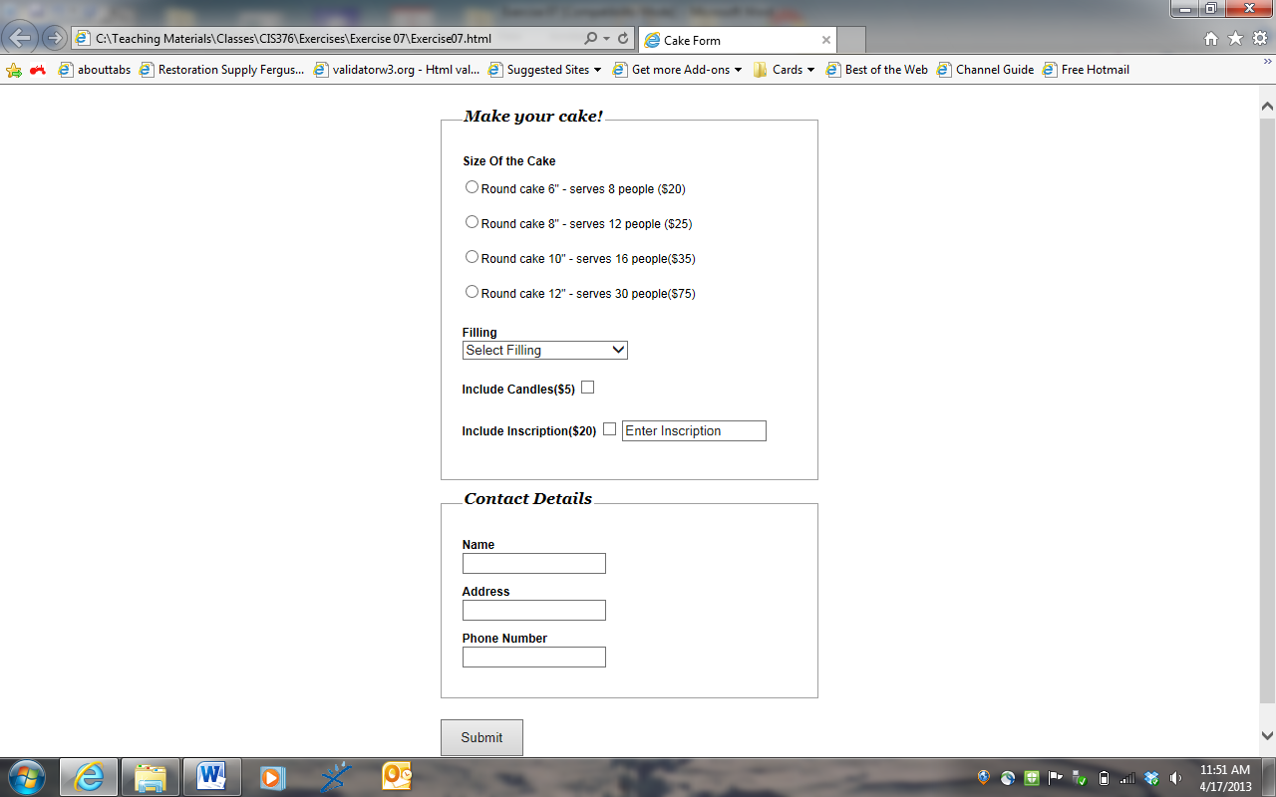
University of Southern Indiana
CIS376 - Intermediate Web Development
Exercise 04

3. Include a return link from Exercise04.html to Menu.html.

4. The source code for the JavaScript should be placed in a file called Exercise04.js.

5. Validate all input fields display appropriate error messages.

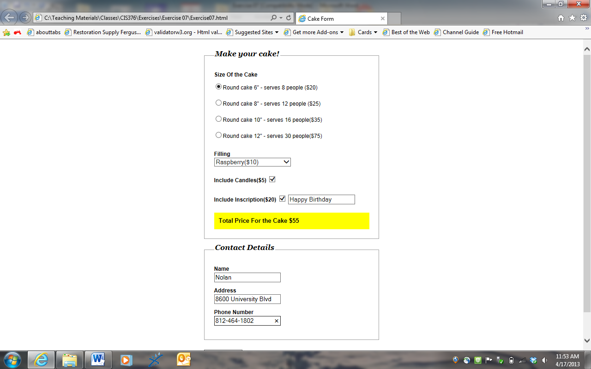

University of Southern Indiana
CIS376 - Intermediate Web Development
Exercise 04

6. Declare and use variables where appropriate.

7. Use document.getElementById("id tag name").innerHTML=variable as the vehicle for updating the HTML page from the JS page.

This assignment is due 10/14/16 at 11:30 PM and is worth 75 points.

